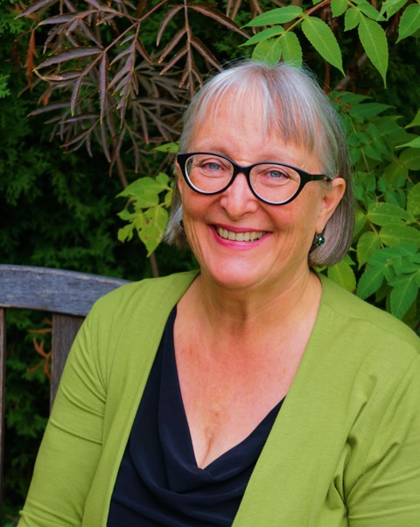
Dancing with Self Compassion

a weekend of movement, music and self connection
blending NIA Technique
and Compassionate Communication
led by
Phyllis Brzozowska
April 21 – 22, Christchurch
(9.30 am to 5 pm each day)
at Addington Haven (map)
a quiet retreat space within walking distance of Hagley Park.
Koha/Donation - $210 to $290 requested
(includes 2 vegetarian lunches and materials - full details pg 3)
Spend a weekend immersed in the felt sense of joy and pleasure through movement as you explore loving yourself and your body from the inside out. Dancing with Self Compassion is an experiential introduction to the dynamic, holistic movement practice of NIA Technique combined with practices that strengthen our capacity for self-compassion.
The Nia slogan “Love your Body, Love your Life” is a guiding vision for this workshop. You will explore transforming your relationship to your body and transforming your relationship to the very essence of who you are. Nia invites us to learn to love ourselves from the “inside out” through moving in ways that bring us joy and pleasure and allow us to thrive. Compassionate Communication likewise invites us into daily practices of holding ourselves with unconditional love and acceptance and to live into the beauty of our hearts’ longings.

Phyllis Brzozowska comes to us from Portland, Oregon. She has been studying NVC since 2002 and has been formally teaching and sharing it with others since 2007. In 2010, an NVC colleague introduced her to the NIA Technique by saying that she thought NIA was “NVC in motion.” Phyllis has completed formal training in NIA at the Black Belt level. As a licensed Nia Teacher, Phyllis conducts weekly classes in Portland and has begun collaborating with NVC trainer Robert Gonzales to incorporate Nia Moving to Heal experiences into Living Compassion workshops and retreats around the world.
Registration and enquiries to Valerie Wycoff 351-7432 or valerie@valeriewycoff.com See Page 2 & 3 for Registration details and more about NVC and Nia

Page 2

NIA Technique is a holistic movement practice that anyone can do. NIA draws on the movement forms of dance, martial arts and the healing arts of yoga, Feldenkrais and Alexander Technique. It’s based on the concepts that through movement we find healing and that the most important relationship we will ever have is our relationship with our body.
Compassionate Communication (or NVC) points to a consciousness of living and communicating from our essential nature and offers principles and practices for embodying empathy, mutuality and authenticity.
Previous experience: You need not have previous NIA or dance experience. It would be advantageous to have done at least 10 hours of introductory study, a foundation course or practice groups with a teacher of Nonviolent Communication. Should you need assistance to find a course or practice group, indicate on your response in preregistration email.

REGISTRATION INFORMATION:
To register: Please contact Valerie Wycoff by phone at 351-7432 or email: valerie@valeriewycoff.com
Places are Limited, so we highly recommend early registration before April 10 preferred.
Please direct credit your total Koha/Donation (suggested range $210 to $290 inclusive of registation)
or send a minimum of $75 to cover registration and hold your place plus remainder of Koha – by April 18
to: JER Lovell-Smith and VM Wycoff 38-9005-0258976-12
Why these numbers:
$75 per participant covers 2 catered vegetarian meals, venue, administration and Phyllis’s accommodation expenses – and so we request this as a minimum to hold your place.
PLUS We also invite a Koha/donation for Phyllis’s teaching ($135 - $215 suggested) Please give as much as you comfortably and joyfully can to support Phyllis and her ongoing sharing of NIA and Compassionate Communication.
For more about Nia and Compassionate Communication (NVC) see page 3
Page 3
More about: NIA and Compassionate Communication (Nonviolent Communication or NVC)
ABOUT NIA
Nia is a holistic experience for mind, body and spirit. It is Nia’s playful, integrative approach that evokes joy, pleasure, comfort and self-expression. Nia is both a movement and a lifestyle practice that fosters vitality and well-being.
Nia was created in 1983 by two pioneers in the holistic fitness industry, Debbie Rosas and Carlos AyaRosas, who were inspired to help people live more meaningful and enjoyable lives in their bodies. They crafted an entirely new approach to fitness fusing the movement forms of dance, martial arts and the healing arts of yoga, Feldenkrais and Alexander Technique. Nia blends Eastern and Western movements and concepts treating the body with love and respect, honoring the system of sustainability inherent in the body. Nia’s philosophy is that through movement we find health and that the most important relationship you will ever have is your relationship with your body.
Born out of the traditional health and fitness industry, Nia is now offered in its “Classic” form in fitness clubs, yoga centers and gyms in over 45 countries around the world. After many years of development and working with a wide variety of ages and physical abilities, another modality evolved within Nia called Moving to Heal. Nia Moving to Heal offers the same dynamic and holistic Nia moves and principals, usually at a slower pace, with focused attention on finding pleasure in the movements, deep body awareness and the intention to feel better in any way that is currently needed. The Dancing with Self Compassion workshop draws primarily from the Nia Moving to Heal approach. And, in Dancing with Self Compassion you can expect, as in every Nia class, whether it’s “Classic” or Moving to Heal, to dance to a wide variety of engaging, soulful, and fun music selections, very purposefully and consciously chosen to deliver the full Nia experience.
ABOUT COMPASSIONATE COMMUNICATION NVC
Just as the mind, body, spirit approach of Nia is about so much more than fitness, Compassionate Communication ( NVC ) is also more than just a communication process or technique. NVC points to a consciousness of living our lives fully and authentically guided by love and transforming any blocks that may keep us from connecting fully to ourselves and others.
You can learn more about Nonviolent Communication as developed by Marshall Rosenberg in this video of Marshall on YouTube.
Nia and NVC together create a dynamic complementary blend of skills for embodying self-love and compassion.

